https://www.youtube.com/watch?v=to30AJm2epQ

Making Inferences
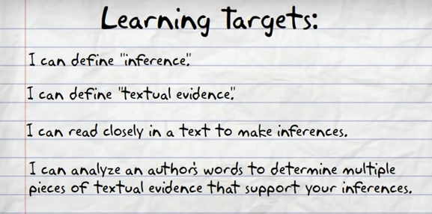

Inferences are educated guesses that we make based on the information that is right in front of us, combined with our own experience.
Inferences are a combination of two things:
1. your background knowledge (schema)
2. what the author tells us
Inferring lets us play detective and try to figure out the hidden parts to a story. 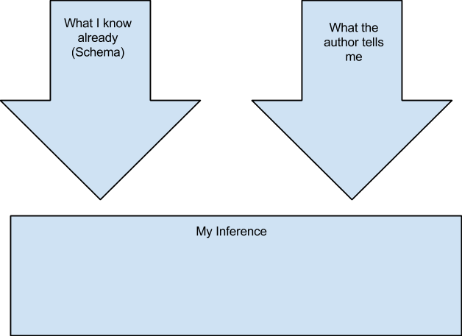
1. Mom helped Katie paint her face 2. She grabbed an empty bag and went out into the night
She must be going trick or treating!
1. Don’t usually paint face white 2. If then going out into the night with a bag, must be something related to the painted face

