Deliberate Word Choice Practice

Adding Specific Details to Enhance
- I was so thirsty after practice on a hot afternoon that I drank two gallons of ( soda / ice cold lemonade / liquid ).
- Exhausted from a long night of studying, I stopped for ( a coffee / some caffeine / a hot mocha latte ) on the way to school.
Substitute with More Vivid Language
- The coach ( said / exclaimed ) that he was disappointed in the team’s performance.
- He ( was mad at / lashed out at ) the players for not doing their best.
- The players were later ( happy / joyful ) when they went undefeated.

Your Turn…Edit the following paragraph to make it more descriptive and detailed. Remember, you can change verbs, add adjectives, add adverbs, and even add specific details.

The boy and girl sat on the beach and watched the sun set. The waves came in to the shore in little ripples, making quiet sounds in the background. He opened a can of cold soda and handed it to her. They said the sunset was pretty, all red, purple, and orange. They watched until the sun was gone, then they went home.

Comparative Superlative Practice
Directions: Put the adjective in bold from the first sentence into the second sentence in its correct form (comparative or superlative).
Example: I have a fast car, but my friend has a car.
Answer: I have a fast car, but my friend has a faster car.

1) This is a nice cat. It's much than my friend's cat.
2) Here is Emily. She's six years old. Her brother is nine, so he is .
3) This is a difficult exercise. But the last exercise is the one of all.
4) He has an interesting hobby, but my sister has the hobby in the world.
5) Last week I read a good book, but father gave me an even one last weekend.
6) That movie was bad, but the movie I saw last week was .
7) Surfing is a dangerous hobby. Bungee jumping is than surfing.
8) This magazine is cheap, but that one is .
9) We live in a small house, but my grandparents' house is even than ours.
10) Yesterday John told me a funny joke. This joke was the joke I've ever heard.

Directions: Complete each sentence with the correct form of the adverb that is in parentheses.
Example: Our father arrived home __________ than the rest of the family. (late)
Answer: Our father arrived home later than the rest of the family.
11) My sister sang ____________________________ than Amanda did. (beautifully)
12) Your husband, Ken, writes ____________________________ of all. (well)
13) Mrs. Henderson speaks ____________________________ than Mrs. Alarcon. (clearly)
14) Mother prepares turkey ____________________________ than Father does. (well)
15) He checked his answers ____________________________ than she did. (carefully)
16) Angelica speaks Spanish ____________________________ of all the students. (correctly)
17) Percy talks ____________________________ than Jennifer. (frequently)
18) She danced ____________________________ of all. (gracefully)

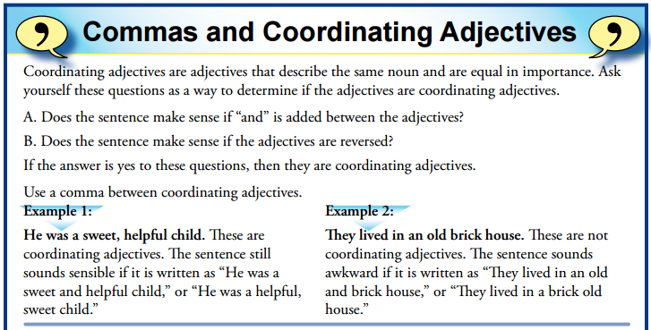

Directions: Rewrite each of the sentences and add commas where they are needed.
- We went down the long dirt road.
___________________________________________________________________________________
- The quiet respectful class listened to the guest speaker.
____________________________________________________________________________________
- The mighty winter storm howled through the night
____________________________________________________________________________________
- They liked the fun surprise party.
____________________________________________________________________________________
- The choir sang a happy merry song.
____________________________________________________________________________________
- I could really go for a hot delicious pepperoni pizza right about now.
__________________________________________________________________________________

