Making Inferences
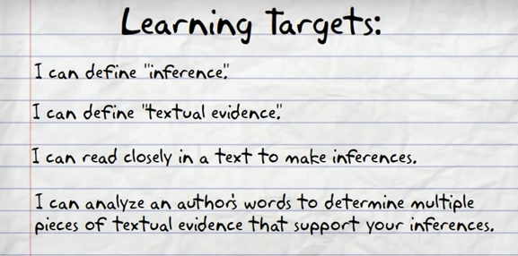

Inferences are ____________________________________________________________________
________________________________________________________________________________________________________________________________________________________________
Inferences are a combination of two things:
1. your background knowledge (schema)
2. what the author tells us
Inferring lets us play detective and try to figure out the hidden parts to a story.