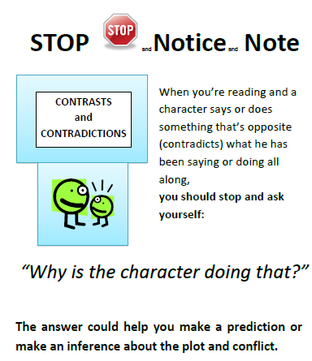 | 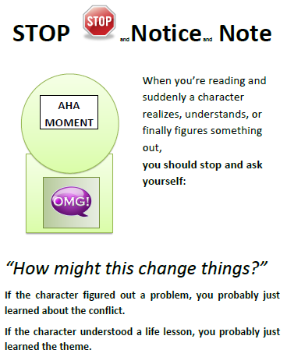 | 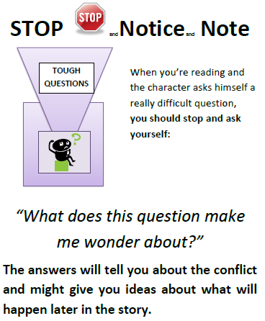
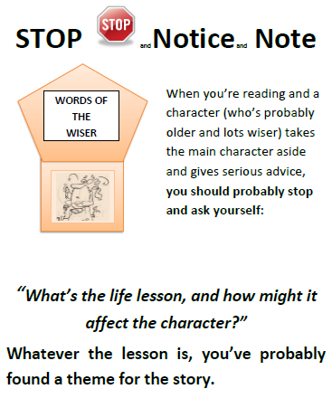 | 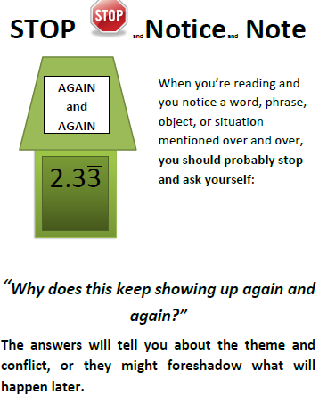 | 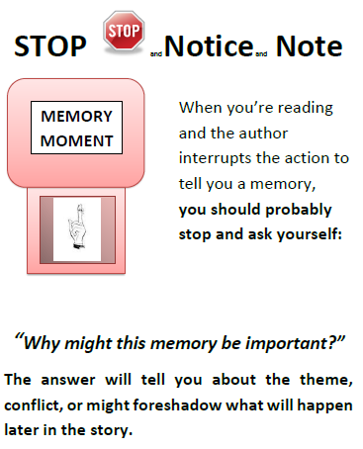

Signposts I found in “Walking with Living Feet” by Dara Horn.
Signpost | Page # | What does the text say? | What literary element from the table (column 3) is developed or connects with the signpost?
Contrast & Contradiction | Pg.84 | Byron tortured and killed a bird then gave it a funeral. (from The Watson’s Go to Bir…) | This demonstrates an internal conflict for Byron. He’s torn between wanting to be bad then feeling sorry for doing the bad thing. This may help to develop the theme later on in the story.

One of our essential questions for this unit is, “How do the themes portrayed in historical text appeal to and relate to contemporary readers?” Use the signposts you noted when reading Walking with Living Feet and the signposts your jigsaw group noted in Night to come up with a list of themes from the two works. Complete the Venn Diagram below.
What themes from the two pieces appeal to you to help you understand the Holocaust better?
Themes I found in Walking with Living Feet
Themes I found in Night

